CSIT 345 Summer 2021 Lab 1 Process Programming

Your lab requirement is to write program codes for 3.21 and shared memory program for producer and consumer as shown in the following. You can start with the code provided in the virtual machine in the virtual box you installed. The code can be found in /home/oscreader/osc9e-src/ch3

1. For 3.21, you can start with the newproc-posix.c and modify the code to meet your requirement. Then type:

**gcc newproc-posix.c** to compile, then type ./**a.out** to execute

( this lab can also be ran on repl.it)

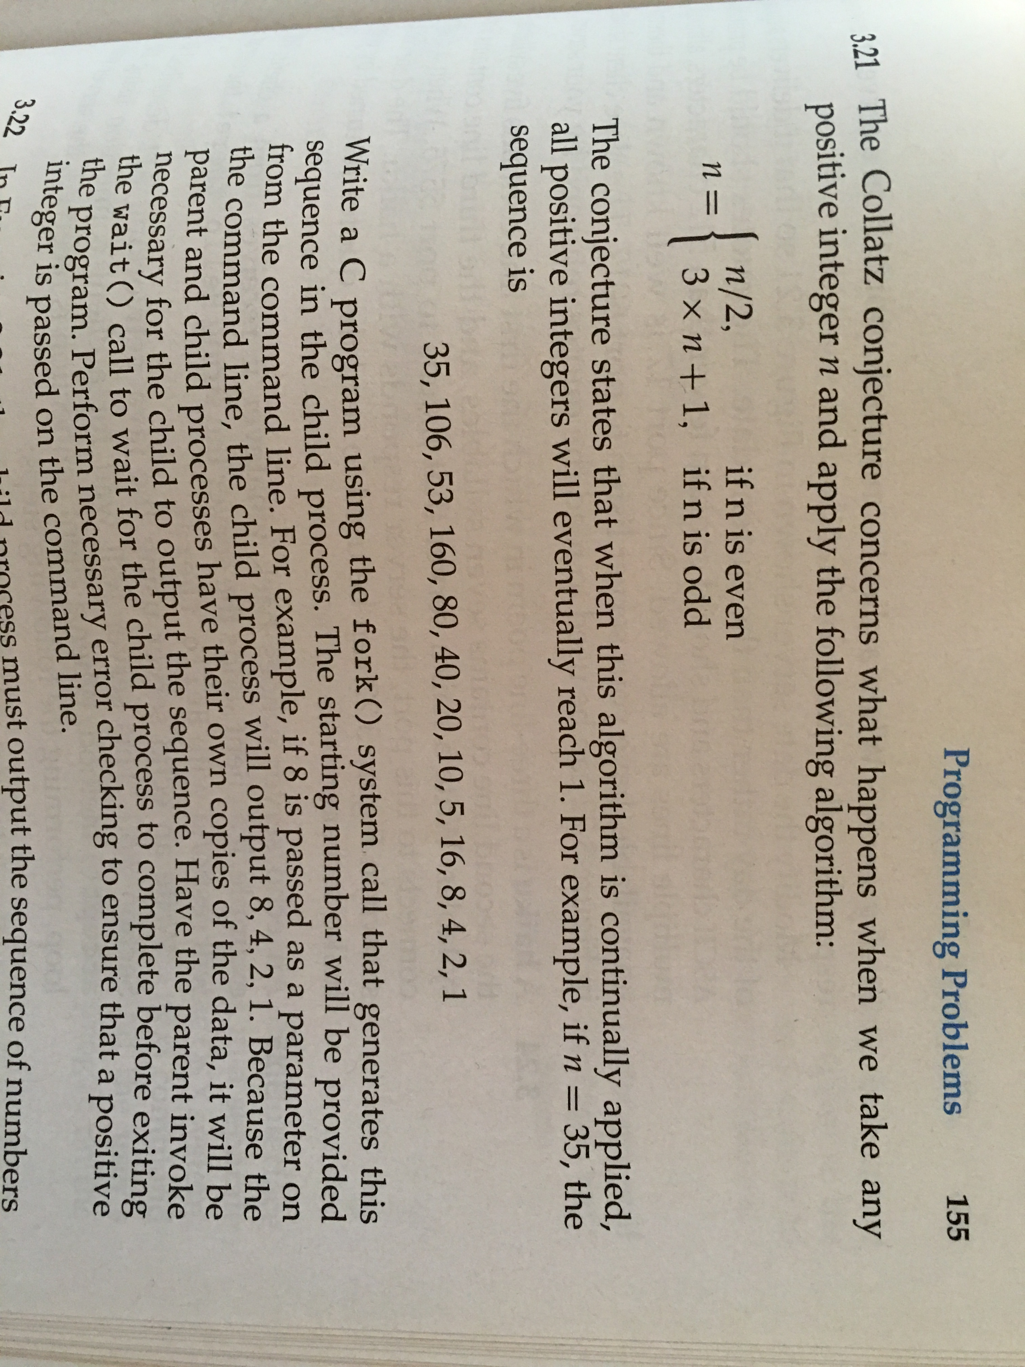

b. You will write two programs, producer and consumer. The producer will generate the sequence of numbers using Collatz conjecture and write it to the shared memory. The consumer will read the sequence of number out from the shared memory. Please start with the code under ~/osc9e-src/ch3: shm-posix-consumer.c and shm-posix-producer.c as the template. Modify the code as needed to fit your needs. When you compile the code, please run the following two commands:

**gcc shm-posix-consumer.c –o consumer –lrt**

**gcc shm-posix-producer.c –o producer –lrt**

Then you should type **./producer** to execute the producer program and then type **./consumer** to execute the consumer program. The consumer program will print out the number sequence on the screen.